PICO-V2K4-SEMI

*With A1.1 Pico-ITX Board*

Engineering Specification

**2022/06/19**

|  |  |  |  |
| --- | --- | --- | --- |
| Dept. | Name | Sign | Date |
| PM | John Liu |  |  |
| Simone Tseng |  |  |
| RD | H/W – Edwin |  |  |
| S/W – Peter |  |  |
| ME – Willie |  |  |
| QE | Mike |  |  |

**TABLE OF CONTENTS**

1. Block Diagram 4

2. SPECIFICATIONS 5

3. BIOS Request 7

4. OS Support Request 8

5. Mechanical Drawing 8

**Revision History**

|  |  |  |  |
| --- | --- | --- | --- |
| Rev | Brief Description of Changes | Date of Issue | Author(s) |
| 0.1 | Board Initial spec | 2021/11/16 | John Liu |
| A1.0 | Board Final SPEC | 2022/4/11 | John Liu |
| A1.1 | Board Initial spec   1. One of LAN chip i210→i226, the other one is i210. 2. Push Type C connector forward 1mm   PICO-SEMI Initial spec   1. One of LAN chip i210→i226, the other one is i210. 2. Push Type C connector forward 1mm 3. Remove LVDS/eDP、COM3/4、USB2.0 4. PICO-V2K4-SEMI chassis is based on PICO-TGU4-SEMI for I/O modification. | 2022/06/19 | John Liu |

# Block Diagram

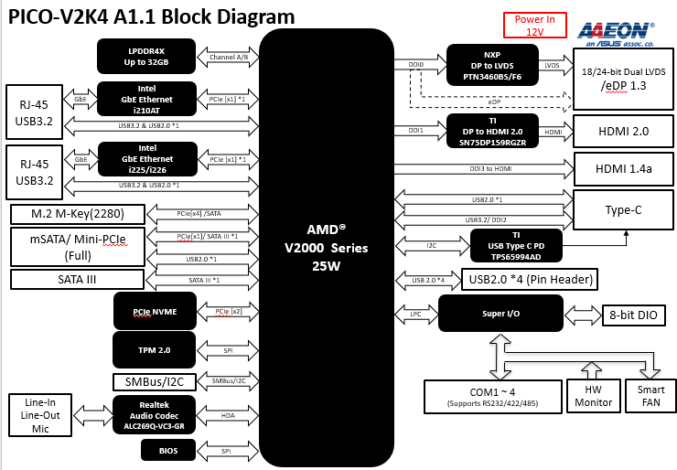

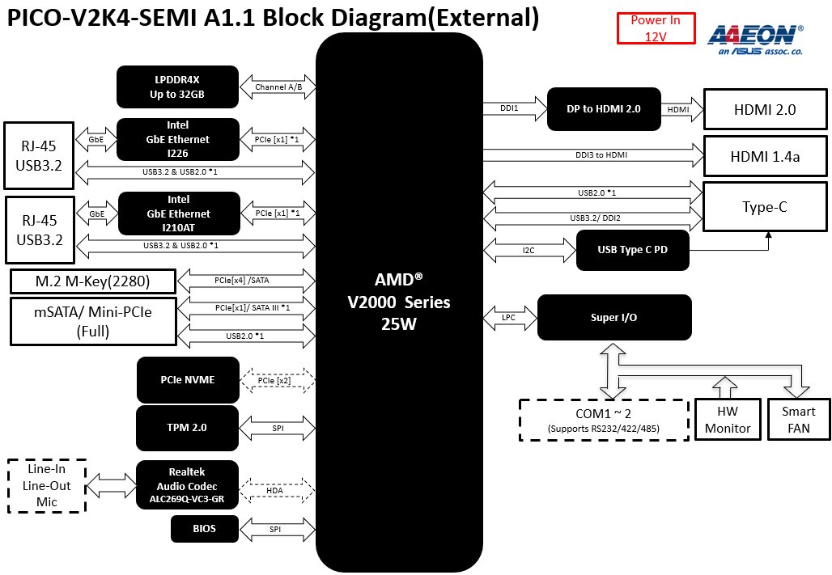

# SPECIFICATIONS (BOARD LEVEL)

|  |  |
| --- | --- |
| Board Level |  |
| Form Factor | PICO-ITX |
| CPU | AMD RYZEN™ V2000 embedded Processor Family  V2718 (8C/16T, 1.7~4.15 GHz, 10-25W) V2516 (6C/12T, 2.1~3.95 GHz, 10-25W) |
| CPU Frequency | Up to 4.15GHz |
| Chipset | AMD RYZEN™ V2000 embedded Processor Family |
| Memory Type | LPDDR4x 3733 MHz on board memory |
| Max. Memory Capacity | Up to 32GB |
| BIOS | UEFI |
| Wake On LAN | Yes |
| Watchdog Timer | 255 Levels |
| Power Requirement | +12V AT/ATX (AT as default) |
| Power Supply Type | Lockable & phoenix Terminal co-lay (phoenix as default) |
| Power Consumption (Typical) | 4.24A at +12V, V2718, LPDDR4x on board 32GB |
| System Cooling | Cooler |
| Dimension | 3.94" x 2.84" (100mm x 72mm) |
| Gross Weight | 0.55 lbs. (0.25 kg) |
| Operating Temperature | 32°F ~ 140°F (0°C ~ 60°C) |
| Storage Temperature | -40°F ~ 176°F (-40°C ~ 80°C) |
| Operating Humidity | 0% ~ 90% relative humidity, non-condensing |
| MTBF (Hours) | TBD |
| Certification | CE/FCC Class A |
| DISPLAY |  |
| Chipset | AMD Radeon 6、7 Graphics (Renoir) |
| Resolution | 1. Type C to DP x 1 2. HDMI 2.0b x 1, 4K x 2K 60Hz 3. HDMI 1.4 x 1, 4K x 2K 30Hz (3840 x 2160)  4. eDP or LVDS x 1 (eDP 1.4: 3840x2160, 60Hz；LVDS: 12V/3.3V, 18-24 bit, single channel) |
| LCD Interface | — |
| I/O |  |
| Storage/SSD | On board NVME SSD (Optional, up to 64GB, PCIE x 2, by BOM)  SATA III x 1 +5V SATA Power Connector x 1 |
| Ethernet | Intel® i225/226, 10/100/2500Base x 1  Intel® i210, 10/100/1000Base x 1 |
| USB Port | USB3.2 Gen2 Type C x 1 (rear I/O) USB3.2 Gen2 x 2 (rear I/O) USB2.0 x 4 (pin header) |
| Serial Port | RS232/422/485 x 4 |
| Audio | High Definition Audio Interface, Line-in/Line-out/MIC(Optional) |
| DIO | 8-bit |
| Expansion Slot | M.2 2280 M-key x 1 (PCIe Gen3 x 4 as default, SATA selected by BIOS)  mini-PCIe(Full) x 1 (PCIe [x1] x 1/ USB2.0 as default, mSATA selected by HW BOM) SMBUS/I2C x 1 (SMBUS as default, I2C selected by HW BOM) |
| SIM | — |
| TPM | 2.0 (Optional) |
| Touch | — |

# SPECIFICATIONS (SYSTEM LEVEL)

|  |  |
| --- | --- |
| SYSTEM Level |  |
| Form Factor | PICO-SEMI |
| CPU | AMD RYZEN™ V2000 embedded Processor Family  V2718 (8C/16T, 1.7~4.15 GHz, 10-25W) V2516 (6C/12T, 2.1~3.95 GHz, 10-25W) |
| CPU Frequency | Up to 4.15GHz |
| Chipset | AMD RYZEN™ V2000 embedded Processor Family |
| Memory Type | LPDDR4x 3733 MHz on board memory |
| Max. Memory Capacity | Up to 32GB |
| BIOS | UEFI |
| Wake On LAN | Yes |
| Watchdog Timer | 255 Levels |
| Power Requirement | +12V ATX |
| Power Supply Type | (DC jack as default) |
| Power Consumption (Typical) | 4.24A at +12V, V2718, LPDDR4x on board 32GB |
| System Cooling | Cooler |
| Dimension | 4.80” x 3.18” x 2.20” (122mm x 80.8mm x 56 mm) |
| Gross Weight | TBD |
| Operating Temperature | 32°F ~ 140°F (0°C ~ 60°C) |
| Storage Temperature | -40°F ~ 176°F (-40°C ~ 80°C) |
| Operating Humidity | 0% ~ 90% relative humidity, non-condensing |
| MTBF (Hours) | TBD |
| Certification | CE/FCC Class A |
| DISPLAY |  |
| Chipset | AMD Radeon 6、7 Graphics (Renoir) |
| Resolution | 1. Type C to DP x 1 2. HDMI 2.0b x 1, 4K x 2K 60Hz 3. HDMI 1.4 x 1, 4K x 2K 30Hz (3840 x 2160) |
| LCD Interface | — |
| I/O |  |
| Storage/SSD | On board NVME SSD (Optional, up to 64GB, PCIE x 2, by BOM) |
| Ethernet | Intel® i225/226, 10/100/2500Base x 1  Intel® i210, 10/100/1000Base x 1 |
| USB Port | USB3.2 Gen2 Type C x 1 (rear I/O) USB3.2 Gen2 x 2 (rear I/O) |
| Serial Port | RS232/422/485 x 2 (optional) |
| Audio | High Definition Audio Interface, Line-out (optional) |
| DIO | — |
| Expansion Slot | M.2 2280 M-key x 1  (PCIe Gen3 x 4 as default, SATA selected by BIOS)  mini-PCIe(Full) x 1  (PCIe [x1] x 1/ USB2.0 as default, mSATA selected by HW BOM) |
| SIM | — |
| TPM | 2.0 |
| Touch | — |
| Qualification Plan |  |
| Anti-Vibration | 5-500Hz ; 2grms |
| Drop | ISTA PROJECT 1A |
| Shock | IEC 68-2-27  10G peak acceleration (11 m sec. duration), operation  20G peak acceleration (11 m sec. duration), non-operation |

# 3. BIOS Request

|  |  |  |  |  |  |  |  |  |  |  |
| --- | --- | --- | --- | --- | --- | --- | --- | --- | --- | --- |
| **Manufacturer** | AMI UEFI BIOS | | | | | | | | | |
| **Core Revision** | N/A | | | | | | | | | |
| **Chipset Name** | AMD RYZEN™ V2000 | | | | | | | | | |
| **TPM** | Yes | | | | | | | | | |
| **iAMT** | No support | | | | | | | | | |
| **SIO** | Fintek. F81966B-I.Rev.D | | | COM1/2/3/4 RS-232/422/485  GPIO * 8bit  Fan control | | | Address: As Standard IRQ: As Standard | | | |
| **Front Side Bus Setting** | N/A | | | | | | | | | |
| **Graphic Option** | Shared memory: Up to 512MB/ DVMT 5.0 | | | | | | | | | |
| TV | N/A | | | | | | | | |
| □CRT | | ■LCD | | □TV | ■HDMI | | □CRT/LCD | | □CRT/TV |
| □CRT/DP | | □LCD/TV | | □LCD/HDMI | □TV/DP | | ■Dual LCD | | □DP++ |
|  | | | | | | | | | |
| **Ethernet** | Boot from LAN support | | | | □ RPL ROM | | | ■ PXE ROM | | |
| Wake on LAN | | | | ■ Yes | | | □ No | | |
| **Audio** | HDA | | PnP | | | | | | | |
| MPU-401 | | N/A | | | | | | | |
| Game Port | | N/A | | | | | | | |
| **Power Supply Type** | AT/ATX | | | | | | | | | |
| **Power Management** | □ APM, Rev: 1.2 | | | | ■ ACPI, Rev: 6.0 | | |  | | |
| **Hardware Monitor** | **Voltage** | | +V5S, +V12S, +VDDCR_VDD, +VDDQ & Temperature from CPU / System side | | | | | | | |
| **FAN** | | ■ CPU | | □ System |  | | |  | |
| **Watchdog Timer** | Minimum Unit | | 1 sec | | | Maximum Unit | | | 255 sec | |
| 255 levels and can be set by software | | | | | | | | | |
| **Boot Device Optional** | □FDD | | ■HDD | | □CD-ROM | □uDOC | | ■LAN | | |
| □USB-FDD | | ■USB-HDD | | ■USB-CD | □CFD | | □Other: | | |
| **Other Features** | SSC Default: Disable or 0%. | | | | | | | | | |

# OS Support Request

|  |  |  |
| --- | --- | --- |
| **Operation System** | **Support** | **Notes** |
| Windows 10 (64 bit) | *V* |  |
| Linux Ubuntu 20.04.3 | *V* | Kernel 5.11 |

# Mechanical Drawing

